User Manual – Manual Sentry

**Subject**: Models & Systems – Prof. Andrea Insaurralde – Afternoon Shift

Technical Secondary School No. 1 ‘Eduardo Ader’

**Group Members:**

• **Leader**: Byron León Ruiz.  
• **Researcher**: Felipe López Mochi.  
• **Documenter & 3D Designer**: Marcos Ezequiel Olivares.  
• **Frontend Developer**: Luciano Iván Fullana.  
• **Backend Developer**: Ariel Lucas Russi.

# **Index**

[**Índice 1**](https://docs.google.com/document/d/16s80qUBdLzMBS1pW3vfOOn2Tue6B3TFuAiO_dk9p6_8/edit?pli=1&tab=t.0#heading=h.jikrttslhne6)

[**1. Introducción 2**](https://docs.google.com/document/d/16s80qUBdLzMBS1pW3vfOOn2Tue6B3TFuAiO_dk9p6_8/edit?pli=1&tab=t.0#heading=h.z03j23sy5zfc)

[1.1 ¿Qué es ManualSentry? 2](https://docs.google.com/document/d/16s80qUBdLzMBS1pW3vfOOn2Tue6B3TFuAiO_dk9p6_8/edit?pli=1&tab=t.0#heading=h.wk4900u6nni9)

[1.2 Objetivo de este Manual 2](https://docs.google.com/document/d/16s80qUBdLzMBS1pW3vfOOn2Tue6B3TFuAiO_dk9p6_8/edit?pli=1&tab=t.0#heading=h.llzg5ivjr2xg)

[1.3 A quién va dirigido 2](https://docs.google.com/document/d/16s80qUBdLzMBS1pW3vfOOn2Tue6B3TFuAiO_dk9p6_8/edit?pli=1&tab=t.0#heading=h.4sb2nh2xf0nc)

[**2. Primeros pasos 3**](https://docs.google.com/document/d/16s80qUBdLzMBS1pW3vfOOn2Tue6B3TFuAiO_dk9p6_8/edit?pli=1&tab=t.0#heading=h.t0myj33guz5u)

[2.1 Requisitos del sistema 3](https://docs.google.com/document/d/16s80qUBdLzMBS1pW3vfOOn2Tue6B3TFuAiO_dk9p6_8/edit?pli=1&tab=t.0#heading=h.2bffbjn5767g)

[2.3 Pantalla de registro del usuario. 4](https://docs.google.com/document/d/16s80qUBdLzMBS1pW3vfOOn2Tue6B3TFuAiO_dk9p6_8/edit?pli=1&tab=t.0#heading=h.gn0ysqd3tcob)

[2.4 Pantalla de logueo del usuario. 5](https://docs.google.com/document/d/16s80qUBdLzMBS1pW3vfOOn2Tue6B3TFuAiO_dk9p6_8/edit?pli=1&tab=t.0#heading=h.q9a07bt83v3u)

[2.5 Descripción general de la interfaz 5](https://docs.google.com/document/d/16s80qUBdLzMBS1pW3vfOOn2Tue6B3TFuAiO_dk9p6_8/edit?pli=1&tab=t.0#heading=h.54ye1wty4747)

[2.6 Funcionalidades principales 6](https://docs.google.com/document/d/16s80qUBdLzMBS1pW3vfOOn2Tue6B3TFuAiO_dk9p6_8/edit?pli=1&tab=t.0#heading=h.oqz717e04947)

[**3. Manejo de hardware y conexión Bluetooth 7**](https://docs.google.com/document/d/16s80qUBdLzMBS1pW3vfOOn2Tue6B3TFuAiO_dk9p6_8/edit?pli=1&tab=t.0#heading=h.x57g4e57yib0)

[**4. Solución de problemas (FAQ). 9**](https://docs.google.com/document/d/16s80qUBdLzMBS1pW3vfOOn2Tue6B3TFuAiO_dk9p6_8/edit?pli=1&tab=t.0#heading=h.b18u69k1y03w)

[**5. Glosario de términos 10**](https://docs.google.com/document/d/16s80qUBdLzMBS1pW3vfOOn2Tue6B3TFuAiO_dk9p6_8/edit?pli=1&tab=t.0#heading=h.lm8env8k749e)

[**6. Anexos 11**](https://docs.google.com/document/d/16s80qUBdLzMBS1pW3vfOOn2Tue6B3TFuAiO_dk9p6_8/edit?pli=1&tab=t.0#heading=h.ifp6m8cr7ud0)

[6.1 Información de contacto de soporte 11](https://docs.google.com/document/d/16s80qUBdLzMBS1pW3vfOOn2Tue6B3TFuAiO_dk9p6_8/edit?pli=1&tab=t.0#heading=h.waohy3rytoi4)

[6.2 Historial de cambios del documento 11](https://docs.google.com/document/d/16s80qUBdLzMBS1pW3vfOOn2Tue6B3TFuAiO_dk9p6_8/edit?pli=1&tab=t.0#heading=h.i1hynx4w0u7m)

# 

# **1. Introduction**

## **1.1 What is ManualSentry?**

***ManualSentry*** is a web application developed to remotely control the user's turret through a visual and intuitive web interface. It allows manipulation of directional movements, firing actions, and access to a control and diagnostic menu via Bluetooth connection.

## **1.2 Objective of this manual**

The purpose of this manual is to provide a clear and detailed guide on using the ManualSentry system, describing its operation, interface, technical requirements, and troubleshooting. It is intended to facilitate the user's understanding of the system's overall operation.

## **1.3 who is it addressed to**

This manual is intended for users who wish to operate their Sentry. No prior experience is assumed, as the system was designed for intuitive operation.

# 

# 2. First Steps

## 2.1 System Requirements

• Supported Browsers: Chrome, Brave, Opera, Microsoft Edge .  
• active Bluetooth connection.

## 2.2 How to access the turret operating system.

The user must access the following address from a compatible web browser (*Google, Brave, etc.*):

[***https://manualsentry.cavernservices.org***](https://manualsentry.cavernservices.org)

After clicking the link, the user will be taken to a login screen. If they do not have an account, they should click the ***"Register"*** button located below ***"Login"***.

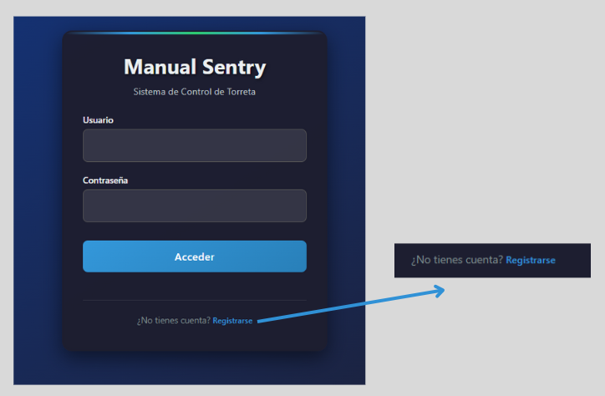

*Website home screen.*

## **2.3** User registration screen.

Upon entering the registration section on the website (accessible via the link below the ***"Login"*** button), you will be able to enter your information: name, email address, password, and confirmation. Your account will be created automatically, and you can access it by returning to the previous page (i.e., ***"Login"***).

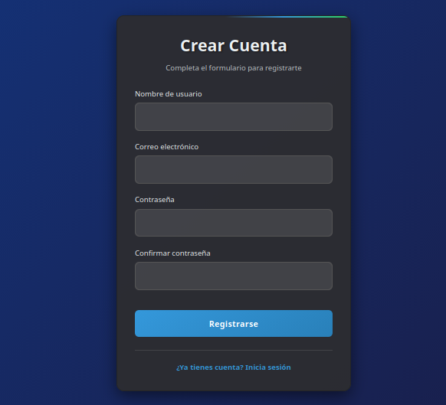

*Creating an account on the ManualSentry website.*

## 

## 

## 

## 

## **2.4** User login screen.

The system includes a login form. Users must enter their credentials to access the control panel. If the password is forgotten, it is recommended to contact the system administrator.

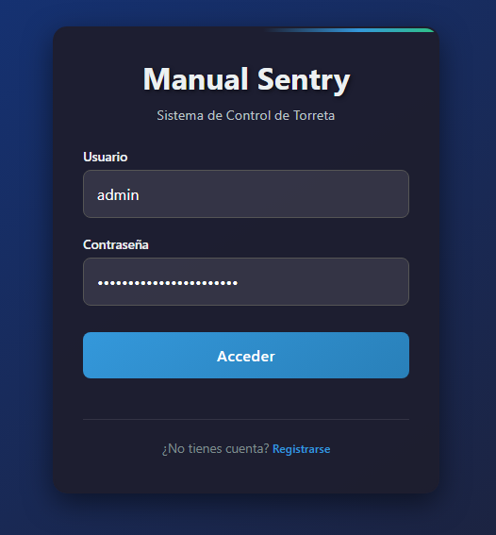

## **2.5** Interface overview

Once authenticated, the user will see the main interface, which consists of a central control screen, a set of directional buttons, and a menu button. These elements allow the user to control the turret's movement and access additional functions.

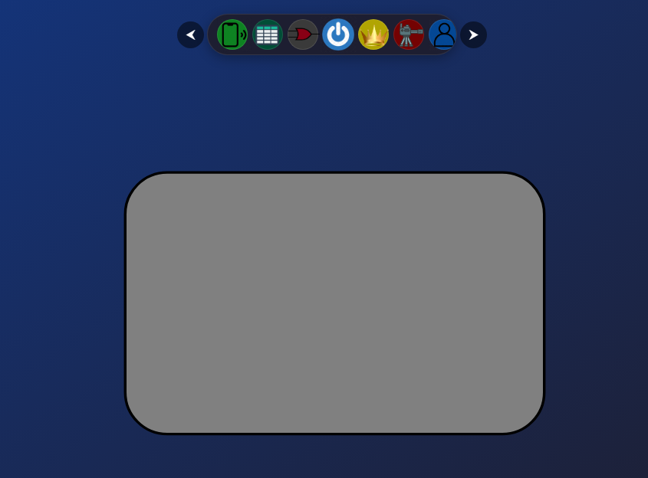

## 2.6 Main functionalities

The main functionalities of the system are divided into the following modules:

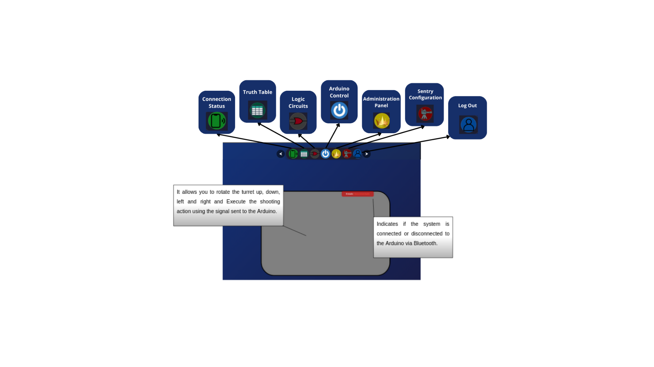

## 

# 3. Hardware handling and Bluetooth connection

To operate the turret, we first need to perform the following steps:

1. Place the batteries in the battery holder.

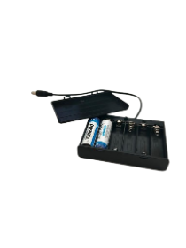

1. Plug the sentry into the battery holder via the corresponding port.

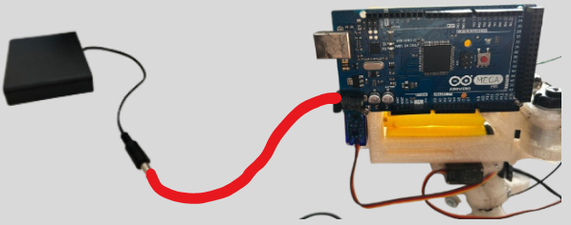

1. Make sure the turret and battery holder are properly connected.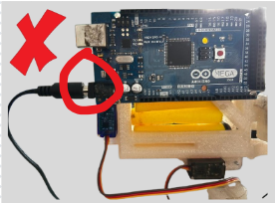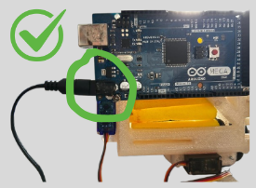
2. Make sure the green light located on top of the turret is on.

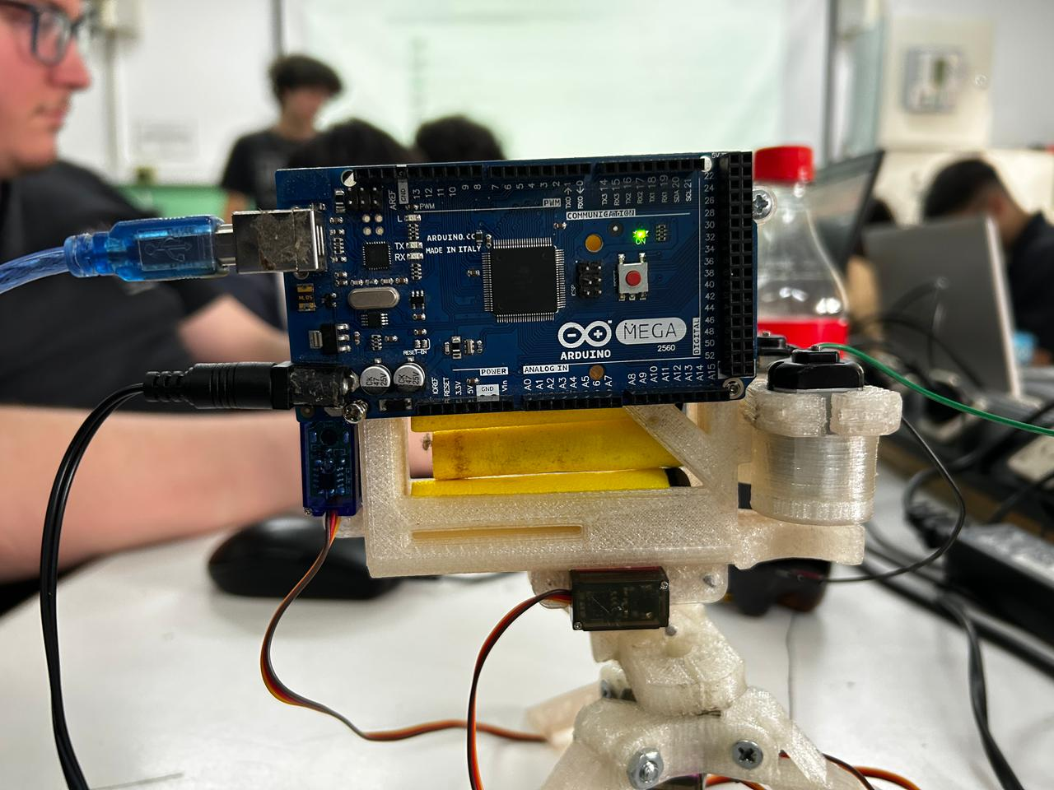

1. Using the account you created, go to the login section.

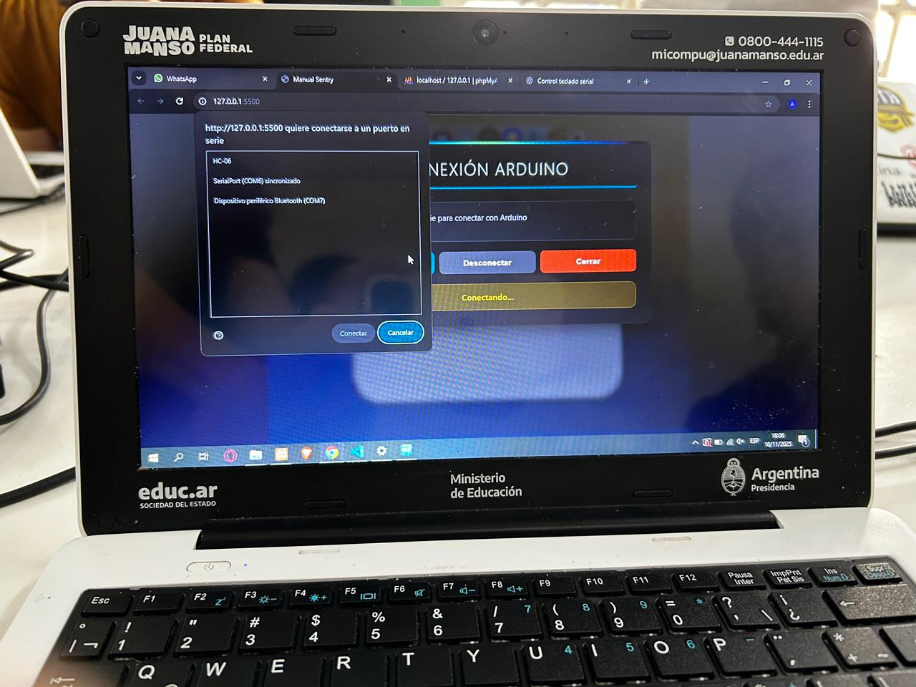

1. In the connection section, click on the ***"connect"*** option. A tab will appear where you can choose the Bluetooth port.



# 

# **4.** Troubleshooting (FAQ).

***Question***: The system won't connect to Bluetooth.

***Answer***: Ensure the device has Bluetooth capability and that the turret isn't paired with another device.

***Question***: The buttons aren't responding.

***Answer***: Refresh the page and check that the connection to the sentry is active.

***Question***: The menu won't open.

***Answer***: Wait a few seconds for the site to load completely before trying again.

# 

# **5.** Glossary of terms

***Bluetooth***: Wireless technology for connecting devices.

***Arduino***: Open-source hardware platform used to control the turret.

***Servo***: Motor that allows precise angular movement.

***Digital*** ***Pin***: Connection on the Arduino that sends or receives electrical signals.

# 

# **6. Annex**

## **6.1** Support Contact

Information Contact email: manualsentry@gmail.com

## **6.2** Document change history

v0.1 – Creation of the first manual – October 17, 2025.

v0.2 – Draft with the requirements requested for the subject – October 24, 2025.

**Document version**: v0.4

**Creation date**: 11/10/2025

**Draft submission date**: 11/14/2025